Module 3: Critical Thinking Assignment

Part 1
Write a program that calculates the total amount of a meal purchased at a restaurant.
The program should ask the user to enter the charge for the food and then calculate the amounts
with an 18 percent tip and 7 percent sales tax. Display each of these amounts and the total price.

Link to GitHub:

Pseudo-code: Using array total and calculating tip, tax, and total then assigning each to an index in total then print array total.

Source Code:

import array as arr
#initialize a float array to store meal cost, tip, tax and total
total = arr.array('d', [])

print("Hello, I hope the meal was good!")

total.append(float(input('Enter the amount for the meal: ')))#input total for meal at index 0 of total array
total.append((total[0] * 0.18)) #append tip into index 1
total.append((total[0] * 0.07)) #append tax into index 2
total.append((total[0] + total[1] + total[2])) #append total + tip + tax

print('The cost of the meal was: $', "%.2f" % total[0])
print('The 18% tip is: $', "%.2f" % total[1])
print('7% Sales Taxes is: $', "%.2f" % total[2])
print("Total for meal is: $", "%.2f" % total[3])

Part 1 Screen Shot in VS-code with Results:

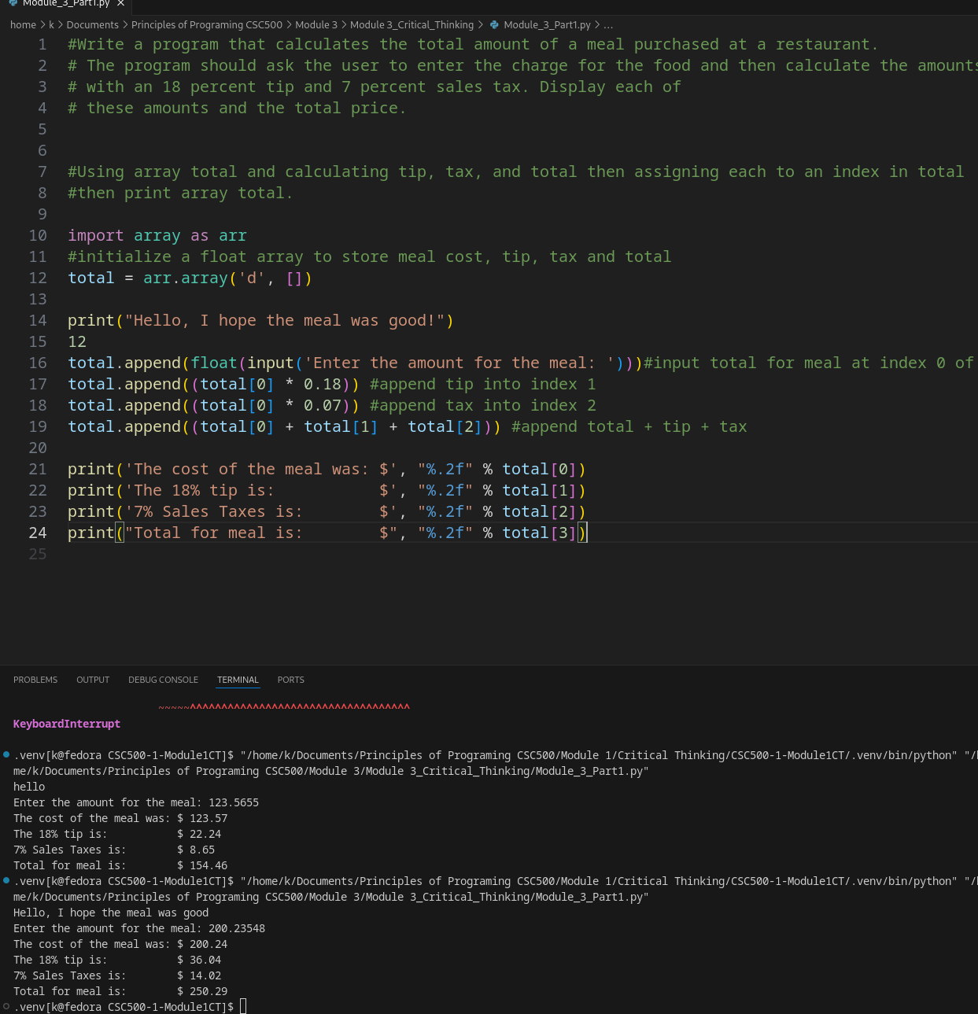

Part 2:
Many people keep time using a 24-hour clock (11 is 11am and 23 is 11pm, 0 is midnight). If it is currently 13 and you set your alarm to go off in 50 hours, it will be 15 (3pm). Write a Python program to solve the general version of the above problem. Ask the user for the time now (in hours) and then ask for the number of hours to wait for the alarm. Your program should output what the time will be on a 24-hour clock when the alarm goes off.
Link to GitHub:

Pseudo-code:
Input the current time in HH:MM format, then while loop to check format of entry.
Print the current time
Input time from now for alarm in HH:MM format
check format of alarm minutes is less than 60 with while
print when alarm will go off from now
if sum of current minutes and alarm minutes is 60 or greater, adjust hour
adjust alarm time hour to report alarm time in 24 time using %
sum current minute and alarm minute
print alarm hour and alarm minute in 24 hr time

Source Code:
#current time input in 24 hr and minute format
current_time = input("Enter time 24 hr format HH:MM\n")

#seperate hour and minute into variables hour
current_hour, current_min = [int(i) for i in current_time.split(":")]

#correct input if not in HH:MM format
while current_hour >= 24 or current_min >= 60:

#current time input in 24 hr and minute format
current_time = input("Enter time 24 hr format HH:MM\n")

#seperate hour and minute into variables hour
current_hour, current_min = [int(i) for i in current_time.split(":")]

#print current time
print("The time now is", current_hour, "hours and", current_min, "minutes")

#input time from now for alarm
time_from_now = input("Enter the amount of time from now for alarm \nin 24 hr format HH:MM\n")
time_from_now_hour, time_from_now_min = [int(i) for i in time_from_now.split(":")]

#check format of minutes for greater than 60
while time_from_now_min >= 60:
time_from_now = input("Enter the amount of time from now for alarm \nin 24 hr format HH:MM\n")
time_from_now_hour, time_from_now_min = [int(i) for i in time_from_now.split(":")]

#print when alarm will go off
print("An alarm will go off ", time_from_now_hour, "hours and ", time_from_now_min, "minutes from now")

#adjust hours if sum of current min and time from now min is equal greater than 60
if time_from_now_min + current_min >= 60:
time_from_now_hour = time_from_now_hour + 1
time_from_now_min = time_from_now_min - 60

#set time from now minute and hour based on 24 hr time
time_from_now_hour = (time_from_now_hour + current_hour) % 24
time_from_now_min = time_from_now_min + current_min

#print what time of day alarm will go off in 24 hr time
print("Alarm set for",time_from_now_hour,"hours and",time_from_now_min,"minutes")

Part 2 Screen Shot in VS-code with Results:
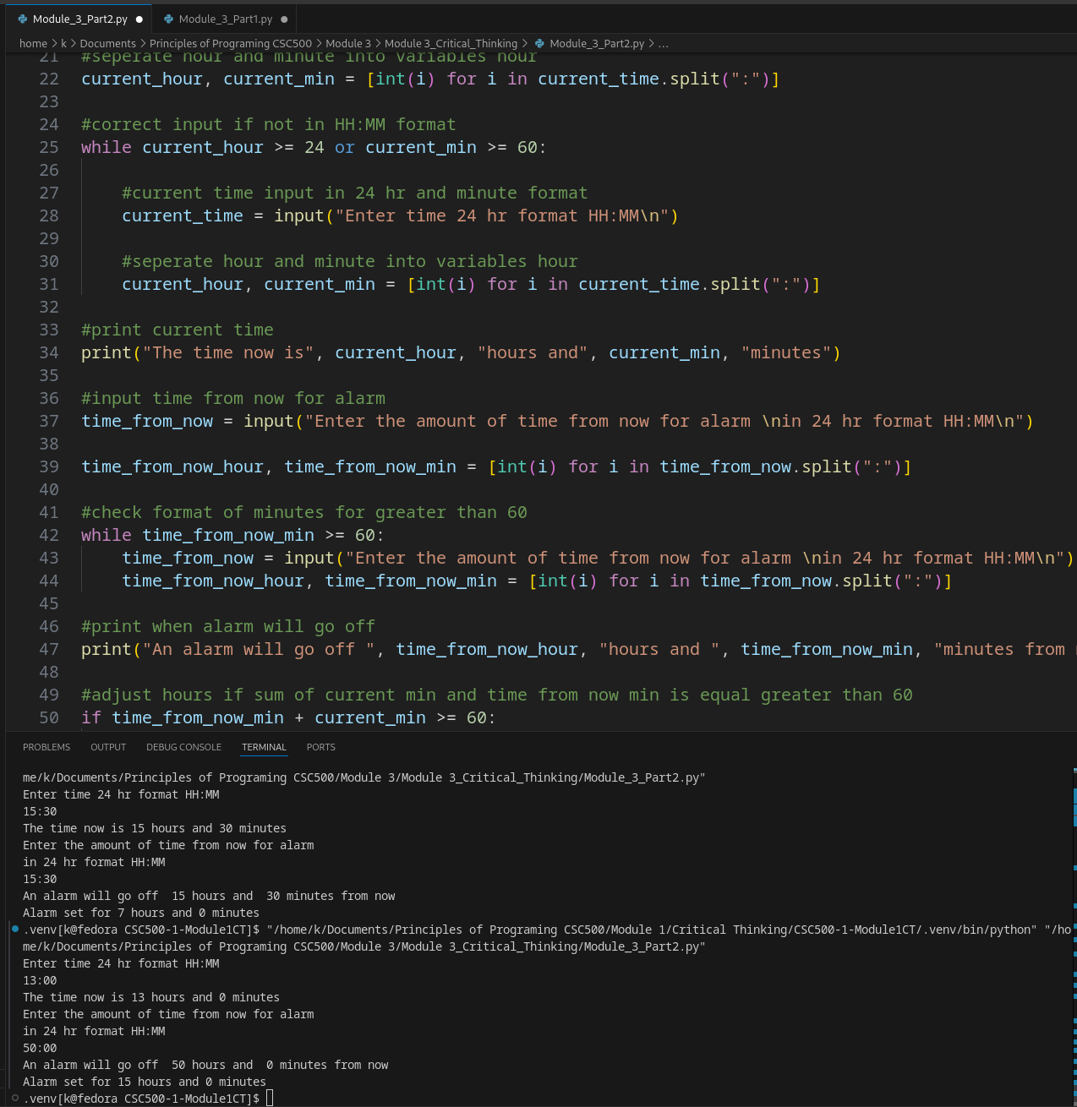

Submission:
Compile and submit your pseudo-code, source code, and screenshots of the application executing the code from Parts 1 and 2, the results and GIT repository in a single document (Word is preferred).

